SET UP MOTORIZED BUG & ROBOTIC PROJECTS
9:00 - 11:00
WED - JULY 18
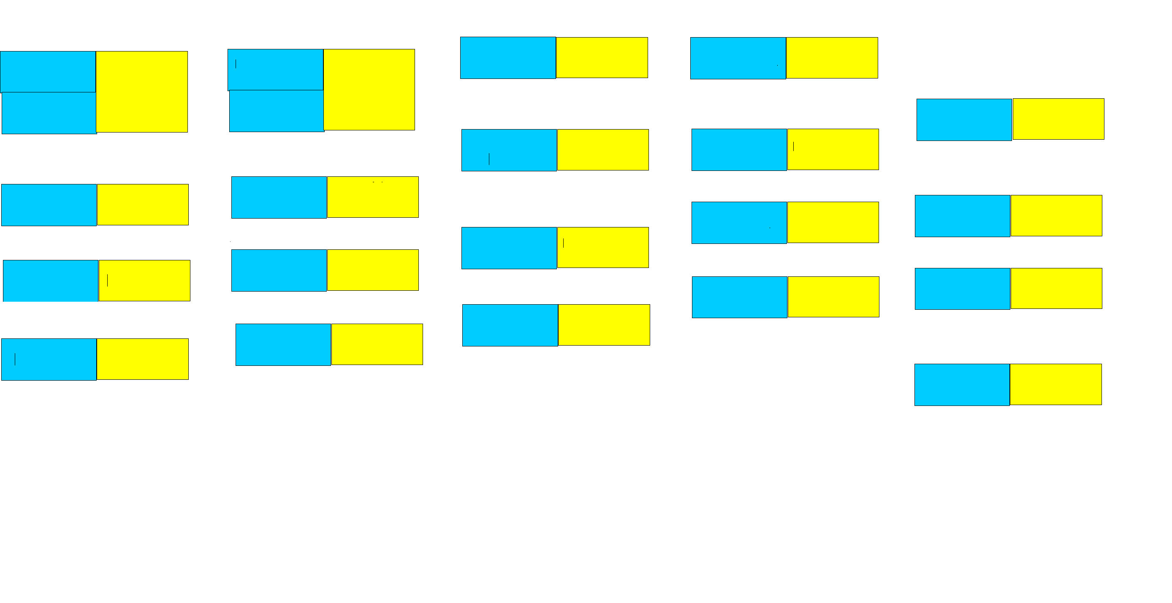
12:00 - 12:30 LUNCH
THURS - JULY 19TH 9:00 - 11 PM
-
11:00 - 11:30 LUNCH
11:30 - 1 PM
11:00 - 11:30 LUNCH
11:30 - 1 PM
2:30 - 4:00
SET DESIGN
SCREEN
PRINTING
BLOCK
PRINTING
COSTUME
PLAY
-
MONDAY - JULY 16TH
9 - 12 PM
MOSAICS
CLAY
CLAY
MOSAICS
ROBOTICS
MOSIACS /
COSTUME
PLAY
BODY
WRAPS
LANDSCAPE
ALCOHOL
INKS
COSTUME
STAGE PLAY
MOSAICS
COSTUME
PLAY
MOSIACS /
COSTUME
PLAY
10:30 - 11:30
PAINT TO
MUSIC
FINISH
PROJECTS
ROBOTICS
OBTAINIUM
WORKS
BLACK CANVAS
BUGS
BLOCK
PRINTING
PHOTO LAB
9 - 12
12:30 - 2 pm
2 - 3:30 PM
3:30 - 4 PM
SPECIAL PROJECTS
PLASTIC BODY WRAPS
SURPRISE BAGS
MONO PRINTS
TUESDAY - JULY 17TH 9:00 - 12 PM-
PHOTO LAB
9 - 12
12:00 - 12:30 LUNCH
12:30 - 2 PM
2 PM - 3:30 PM
3:30 - 4 PM
PHOTO TRIP TO MARE ISLAND
FRI - JULY 20TH 9:00 - 11:30 PM
FINISH ALL PROJECTS - FACE PAINTING
11:30 - 12:00 LUNCH DELL’S HOTDOGS
12:00 - 1:30
PHOTO
COLLAGE
BOX
1:30 - 2:30
PAINT TO
MUSIC
OBTAINIUM WORKS & ROBOTICS
SET UP FINISHED PROJECTS FOR SHOW
MAX & SHANNON TO DETERMINE TIME FRAME
PAINT TO MUSIC - KEVIN FRAZIER
2:30 - 4:15
ALL REHEARSE PLAY
4:30 GUESTS ARRIVE FOR
EXHIBITION & PERFORMANCE
OBTAINIUM
WORKS
ROBOTICS
LANDSCAPE RAGING RIVERS
PHOTO
TRANSPARENCY
Mono
Prints
PHOTOGRAPHY
PHOTO CRITIQUE
BODY
WRAPS
BLACK CANVAS
BUGS
1 PM - 3 PM
1 - 2:30 PM
PHOTOGRAPHY
PHOTO CRITIQUE
BLACK CANVAS
BUGS
PHOTO
COLLAGE
BOX
3 - 4 PM
LANDSCAPE RAGING RIVERS
BLACK CANVAS
BUGS
LANDSCAPE RAGING RIVERS
LANDSCAPE RAGING RIVERS
MOSIACS

