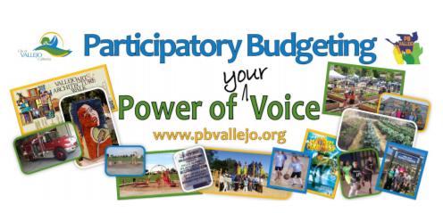
November 13, 2019

Summary
We believe that the Vallejo Waterfront can serve as a vibrant City Center where the residents and visitors can enjoy that beautiful waterway year-round. We are aware that there is an extensive waterfront project in the works for the Central and Northern Waterfront areas and that implementation of the project has been long in the making. We would like to propose interim beautification projects that will enhance the use and enjoyment of the waterfront until the larger development project is complete.

The funding requested would finance the Vallejo Waterfront Park Project (the waterfront on the North and South side of the ferry terminal all west of Mare Island Way), which already has an approved schematic design. This would allow the next phase in line to be completed which not only provides a beautification of the waterfront itself but provides more momentum and inertia for further fundraising towards completion of the overall Waterfront Park project.

Project name and source code
Beautification of Downtown and Waterfront, source codes PB-6, PB40, PB-72, PB-73, PB-82, PB-83, PB-89.

Need and Benefit
This $300K would provide an addition to the Waterfront Park that beautifies Vallejo’s waterfront, expands public enjoyment and access, has a positive economic development affect on local business on and near the waterfront and last but not least, beautify what is one of the main entry points of Vallejo – over 1.2M ferry riders walk this area on their way to/from the Ferry each year and the number is intended to grow rapidly over the next decade.

Who will be the Implementing Partner?
As with the other aspects of Waterfront Park Project, this will be implemented by the contractor already selected by the City for the Waterfront Project, Callahan Property Company, and overseen/managed by The City Manager, and The Economic Development Division,

Who is working on it (lead and others)
Ireta Morris, Christa Anderson, and Ylonda Calloway.

Challenges or questions?

