COLOR MIX

MONDAY - JULY 9TH 8:30 - 9:30 CHECK IN
9:30 - 10:30 - 9:00 - 10:30 9:00 - 11:00
THURS - JLY 12TH 9:00 - 11 PM

TUESDAY - JULY 10TH | WED - JULY 11TH  -

PERSPECTIVE
DRAWING
ROBOTICS
OBTAINIUM
WORKS
OBTAINIUM
WORKS
ROBOTICS
ROBOTICS
OBTAINIUM
WORKS
FRI - JULY 12 9:00 - 11 PM

PHOTOGRAPHY
SCREEN
PRINT

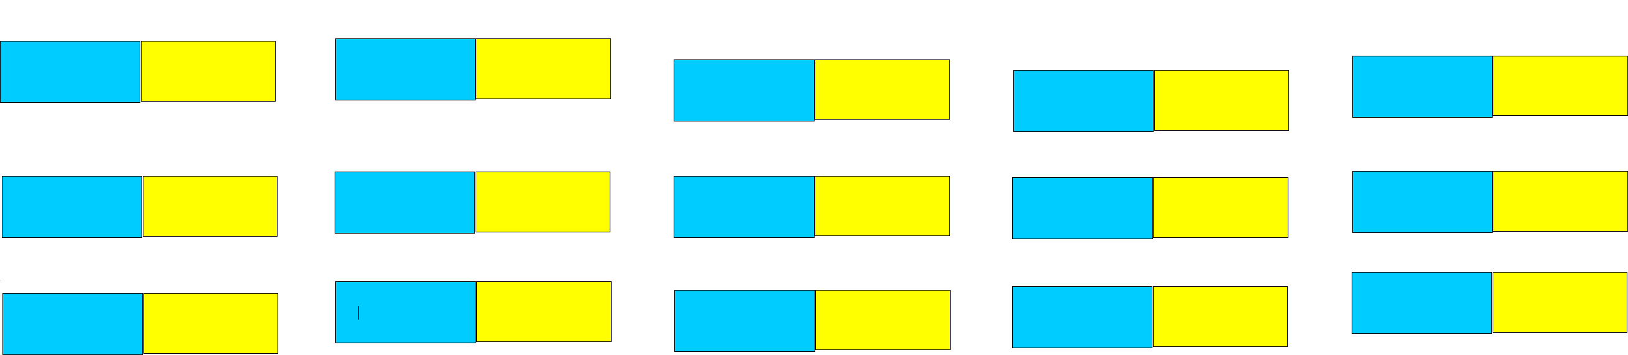
ALCOHOL
INKS
12:30 - 1 PM LUNCH 11:00 - 11:30 LUNCH
1 PM - 3 PM
2 - 3 PM 2:30 - 3:30
BUG LAB
1 - 2 PM 11:30 - 1 PM 1 - 2:30 PM
COSTUME
PLAY
10:30 - 12:30 10:30 - 11:00
MOSAICS
COSTUME
PLAY
BUG LAB
CLAY
BUG
SKETCHBOOK
MOSAICS
MOSIACS
BUG
SKETCHBOOK
CLAY
11:00 - 11:30 LUNCH
11:00 - 11:30 LUNCH 11:00 - 11:30 LUNCH
MOSAICS
PHOTOGRAPHY
PERSPECTIVE
DRAWING
11:30 - 1 PM
PHOTOGRAPHY
MOSAICS
ALCOHOL
INKS
 |  |  | 1 PM - 2:30
1 PM - 3 PM
 |  |  | ROBOTICS | MOSAICS
CLAY | MOSAICS |  | ROBOTICS | MOSAICS
CLAY | MOSAICS |  | 2:30 - 4
3 - 4 PM
 |  |  | LANDSCAPE PAINTING RAGING RIVERS | SCREEN  PRINT
BLOCK  PRINTING | COSTUME  PLAY |  | LANDSCAPE PAINTING RAGING RIVERS | SCREEN  PRINT

11:30 - 1 PM
11:30 - 1 PM
MOSAICS
CLAY
MOSAICS
PHOTOGRAPHY
3 - 4 PM

COSTUME
PLAY
3 - 4 PM 3:30 - 4 PM
COSTUME
PLAY
COSTUME
PLAY
PERSPECTIVE  DRAWING | COLOR MIX |  | COSTUME  PLAY

COSTUME
PLAY
BLOCK PRINT - 7-10 SILK SCREEN - 11-14

INSTRUCTORS:

PHOTOGRAPHY
PLAY ONSTAGE AT LOMA VISTA FARMS
COSTUMES IN GREEN ROOM
AGES 7-10 - CHERYL ANN SHANKS VOLUNTEER - BARB DUVAL
AGES 11-14 - ANDREA NICKERSON VOLUNTEER CHARLES BARNES
LEAD VOLUNTEER - CHARLES BARNES - FULL 2 WEEKS - ASSIT WITH CHECK-IN FIRST DAY - BODY WRAPS VOLUNTEERS - RAMONA SAMPAYAN - BRANDON BORROYO - TINA ARRIOYA - DEBORAH MACDONALD FULL 2 WEEKS DARCIE OBRIEN - ALL DAY WED JULY 11TH
BARB DUVALL - 9TH - 12TH - MORNINGS ONLY - KIDS 7-10
KEVIN FRAZIER - FRIDAY JULY 20TH
INTERN - OROBOSA OLUTU - FOCUS AGES 7 - 10
BARB DUVALL - ALCOHOL INKS - ASSIST WITH MOSIACS - PHOTOGRAPHY
BUG SKETCHBOOK - CLAY - PERSPECTIVE DRAWING MAX CHAO - ROBOTICS
SHANNON & KATHY O’HARE OBTAINIUM WORKS ANDREA NICKERSON - SCREEN PRINT & BLOCK PRINT
CHERYL ANN SHANKS - COLOR MIXING - MONOPRINTS OIL PASTELS
ASSIST WITH BODY WRAPS - PHOTO TRANSPARENCY DEBORAH MACDONALD - MOSIACS - ALCOHOL INKS
BRIAN O’REILLY - PHOTOGRAPHY - PHOTO COLLAGE BOXES - PHOTO LAB
MOBIL PHOTO LAB - IAN RUHTER
CRISTINA ARRIOYA - STAGE PLAY & SET DESIGN RAMONA SAMPAYAN - COSTUME & SET DESIGN KEVIN FRAZIER - PAINTING TO MUSIC
BILL BLOOM - CLAY & GLAZING
SUSAN MACDONALD - LANDSCAPE ALCOHOL INKS - BLACK CANVAS BUGS PHOTO COLLAGE BOXES
DARCIE OBRIEN - ALL DAY WED - PERSPECTIVE DRAWING - LOMA VISTA FARMS STAGE PLAY
RENEE KALE - FACE PAINTING

