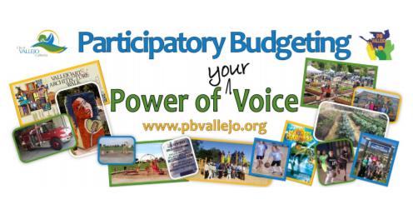
November 13, 2019

Summary
We believe that the Vallejo Waterfront can serve as a vibrant City Center where the residents and visitors can enjoy that beautiful waterway year-round. We are aware that there is an extensive waterfront project in the works for the Central and Northern Waterfront areas and that implementation of the project has been long in the making. We would like to propose interim beautification projects that will enhance the use and enjoyment of the waterfront until the larger development project is complete.

The funding requested would jumpstart the next phase of the Vallejo Waterfront Park Project (the waterfront on the North and South side of the ferry terminal all west of Mare Island Way), which already has an approved schematic design. This would allow the next phase in line to be completed which would not only provide the next step to beautification of the waterfront itself but would provide more momentum and activity for further fundraising towards completion of the overall Waterfront Park project.

Project name and source code
Beautification of Downtown and Waterfront, source codes PB-6, PB40, PB-72, PB-73, PB-82, PB-83, PB-89.

Need and Benefit
This $300K would start the addition to the Waterfront Park project that beautifies Vallejo’s waterfront, expands public enjoyment and access, and have a positive economic development affect on local business on and near the waterfront and last but not least, beautify what is one of the main entry points of Vallejo – over 1.2M ferry riders walk this area on their way to/from the Ferry each year and the number is intended to grow rapidly over the next decade.

Vallejo residents need and would welcome a place close to home where to could enjoy the best of what Vallejo has to offer – the Vallejo Waterfront. Even though the waterfront currently has only a few restaurants and the space has mostly large areas of balding grass, it is still widely used by residents to walk, exercise, or just to sit on the benches to enjoy the weather. This waterfront has so much potential - not only can it be a space that residents can enjoy, this waterfront has unlimited potential to increase economic growth, art and cultural programs, tourism, etc., which will benefit all Vallejo residents who would not have to leave the City in order travel to other recreational areas in the Bay Area.

Who will be the Implementing Partner?
As with the other aspects of Waterfront Park Project, this will be implemented by the contractor already selected by the City for the Waterfront Project, Callahan Property Company, and overseen/managed by The City Manager, and The Economic Development Division,

Who is working on it (lead and others)
Ireta Morris, Christa Anderson, and Ylonda Calloway.

Challenges or questions?
The challenge to this project is that it has been so long in the making. The city of Vallejo has already adopted the Waterfront/Downtown Master plan, we couldn’t find any updates on the projects since January 2019. We hope to be able to contact the projects stakeholders in order to find out the current status of the project. We hope that the funding that we are requesting would jumpstart the next phase of the waterfront project.

